Ideation Phase
Define the Problem Statements

Date | 19-02-2026
Team ID | LTVIP2026TMIDS34682
Project Name | BOOKNEST
Maximum Marks | 2 Marks

Customer Problem Statement Template:
Create a problem statement to understand your customer's point of view. The Customer Problem Statement template helps you focus on what matters to create experiences people will love.
A well-articulated customer problem statement allows you and your team to find the ideal solution for the challenges your customers face. Throughout the process, you’ll also be able to empathize with your customers, which helps you better understand how they perceive your product or service.
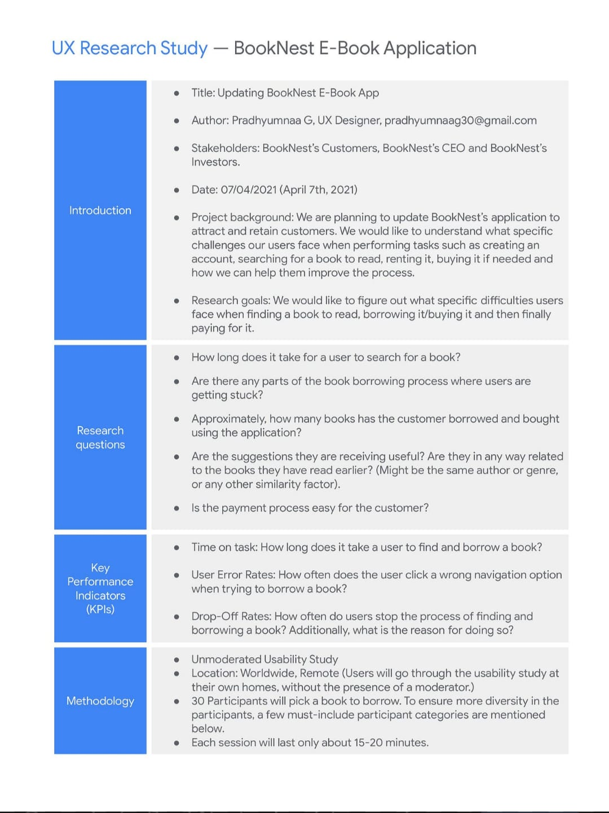

Reference: https://miro.com/templates/customer-problem-statement/
Example:

Problem Statement (PS) | I am (Customer) | I’m trying to | But | Because | Which makes me feel
PS-1 | I am a library use | I’m trying to find and book books easil | But I cannot check book availability onlin | Because there is no centralized digital platfor | Which makes me feel frustrated and wastes my tim
PS-2 | I am a library use | I’m trying to locate specific books quickl | But I have to search manually in the librar | Because there is no proper online search syste | Which makes me feel tired and inefficien
PS-3 | I am a book buyer/use | I’m trying to maintain a wishlist of book | But there is no system to save and track book | Because there is no proper online search syste | Which makes me feel inconvenien
PS-4 | I am a book selle | I’m trying to manage and update book listing | But there is no dedicated dashboar | Because traditional systems do not provide wishlist feature | Which makes me feel difficult to manage inventor
PS-5 | I am an administrato | I’m trying to manage users, sellers, and booking | But there is no centralized management syste | Because the system is manual and not automate | Which makes me feel inefficient and increases workloa

